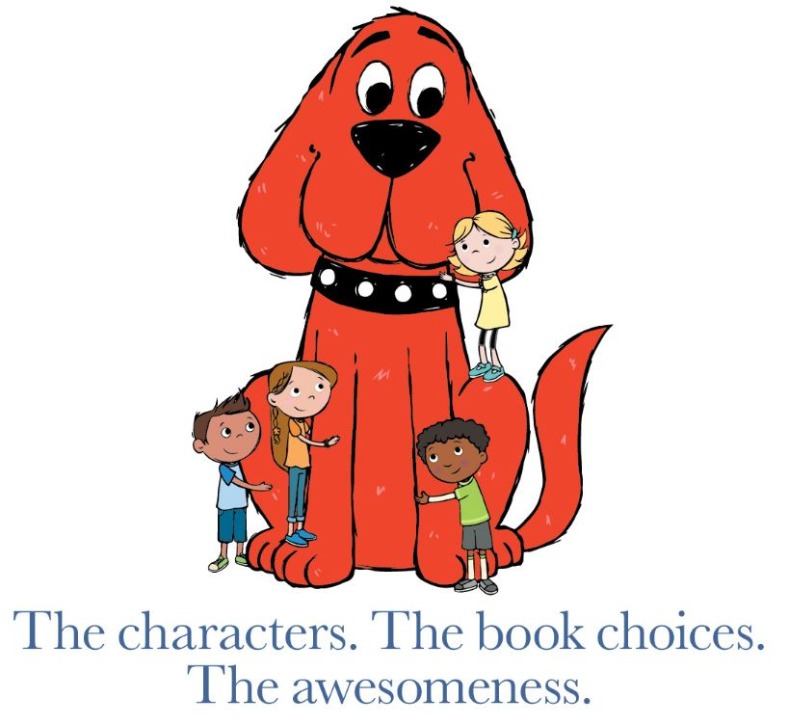
Dear Families:

Our school will celebrate the power of reading at the upcoming Scholastic Book Fair. You are invited to help our school create a culture of reading, build our school libraries, and you will have the opportunity to shop and select books with your child for your home library! A portion of all the proceeds will go back to our school – your support makes a difference!

The more your children read with you at home, the better their comprehension, vocabulary, and fluency. Check out this reading research and find more information on how you can support your child’s reading life at home:
http://s-bf.com?u=48xm

Please mark your calendars to visit our online Book Fair and help your child discover their next favorite book. You can find additional information about the Book Fair on our school website. www.logan326.net Just click on digital links to our Advertised Title Flyer for a sneak peek of some of the product you will find!

Save the date!
Book Fair dates: April 12 – 25, 2021
Shopping hours: 24/7

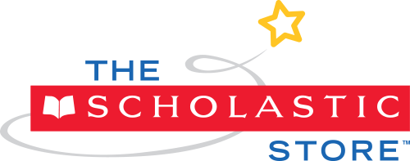
New Online Shopping Option! Shop The Scholastic Store online and choose from over 6,000 items! All orders ship direct to home and book-only orders over $25 ship free. Plus, all purchases benefit our school. Visit our homepage to get started: https://www.scholastic.com/bf/loganelementaryschool17

Happy shopping at our online Book Fair! Until then, happy reading!

Yours truly,

David Kirkendall
Principal

Logan District #326

